# Introduction

“Design Thinking is a **human-centered** approach to innovation *that draws from the designer's toolkit to integrate the* ***needs of people****, the* ***possibilities of technology****, and the* ***requirements for business success****.”*

Design thinking is a powerful thing to tackle unknowns, it is like going on Odyssey without a map but going with a belief and confidence of ending somewhere great . Design thinking is a formal method for practical, [creative](https://en.wikipedia.org/wiki/Creativity)- resolution of problems and creation of solutions, with the intent of an improved future result. In this regard it is a form of solution-based , or solution-focused thinking – starting with a goal of a better future situation instead of solving a specific problem.

As the means of design thinking is not merely solving a specific problem it has a vast impact in each and every field of life. It basically makes us think and analyze each and every parameter, it has a great importance in building a greater future. With the design thinking approach idea can go beyond its limit. It allows us to think divergently which yields into the ability to offer different, unique or variant ideas adherent to one theme rather than convergent thinking to find the "correct" solution to the given problem. Design thinking encourages divergent thinking to ideate many solutions (possible or impossible) and then uses convergent thinking to prefer and realize the best resolution.

The basic idea when I started design thinking was to make technology more user friendly and bring simples on faces. So I started from learning from people what they actually the change they need ,their problems and their temporary solution for a particular problems . Then and I put all problem to gather and tried to find out a pattern for an opportunities .Cluster of patterns have something in common that basically leads to proper idea what can be done next .The more I observer more getting clear with my concept.

**Importance of Team building:**

The design process is a collaborative one, where multi-functions, disciplines and stakeholders work together in addressing the issue. The dialogue during the process on the one hand involves persuasive argumentation and on the other, it should foster commitment amongst the stakeholders.

For producing more efficient design it is required to form a multicultural team. While working in team persons can collaborate different ideas and implement it. It is also required that though there are different minds in members of the team but their goal has to be somewhat similar then and then they can work together. So team building is a very important process for any project to be completed successfully. Every team must have members with following qualities:

* Project Organiser (who manages all the project)
* An analyser (who can do analysis of data)
* Stream wise technical Skill person (Mechanical, Electronics, Software and etc.)
* Concept Ideator (Person who visualise the Idea a solution for the problem)

**Importance of log book exercises:**

* An engineering logbook is a personal/professional reference about project learning and results.
* These records may become necessary to provide a history of the design if there is a turnover in staff, if patent applications are made, or in the case of legal action where the demonstration of professional practices is necessary.
* Monitor and control where you invest your time,
* Learn and apply the best practices for your profession
* Regularly take time to learn from successes and failures

# Chapter 2 : Preparation of Canvases based on different phase of Design Thinking

2.1 Empathy Phase

Social network like Facebook, Twitter, Amazon, E-Bay and many more are collection of large data uploaded by user. To analysis all information and details uploaded by people of that social network .we are thinking to make system which analysis and find particular pattern in which needed. So to make it easier and to make this system more transparent.

**User:**

In this section focus is on gaining understanding of the user. Who is going to use our solution? As this is empathy canvas the focus is more on user’s fillings.

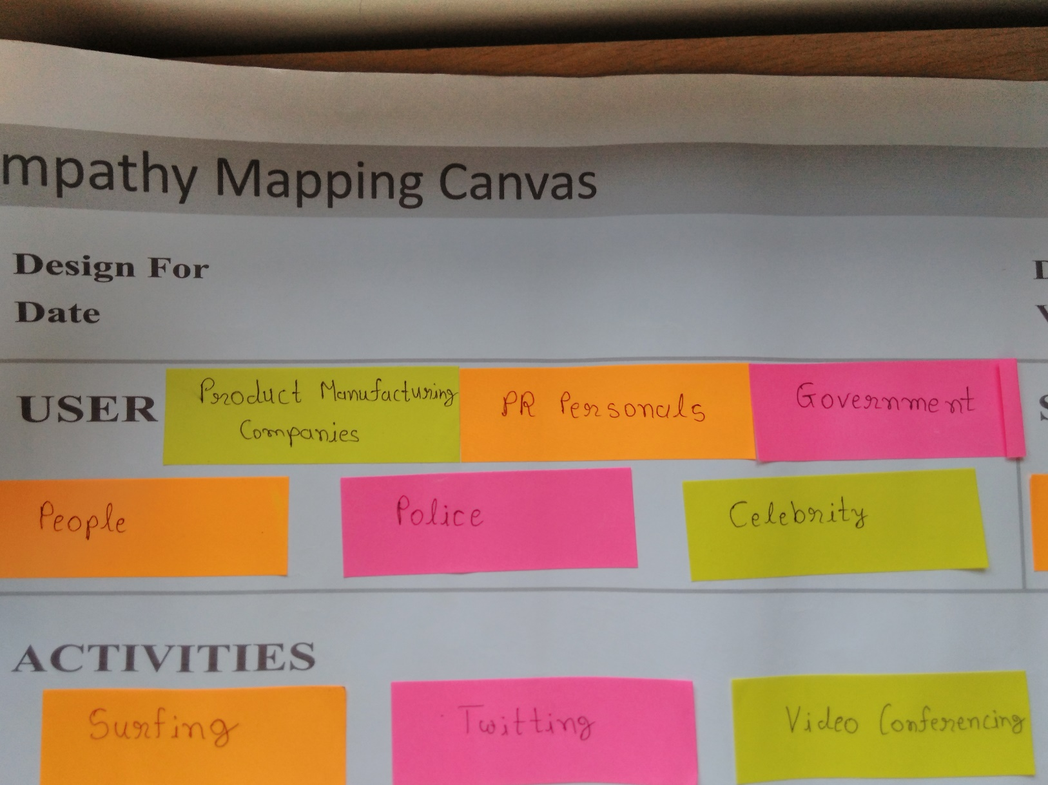

Figure 1 User

**Stakeholders:**

Stakeholders are the ones who are going to endorse us for our solution. They are the ones who are going to use our solution commercially.

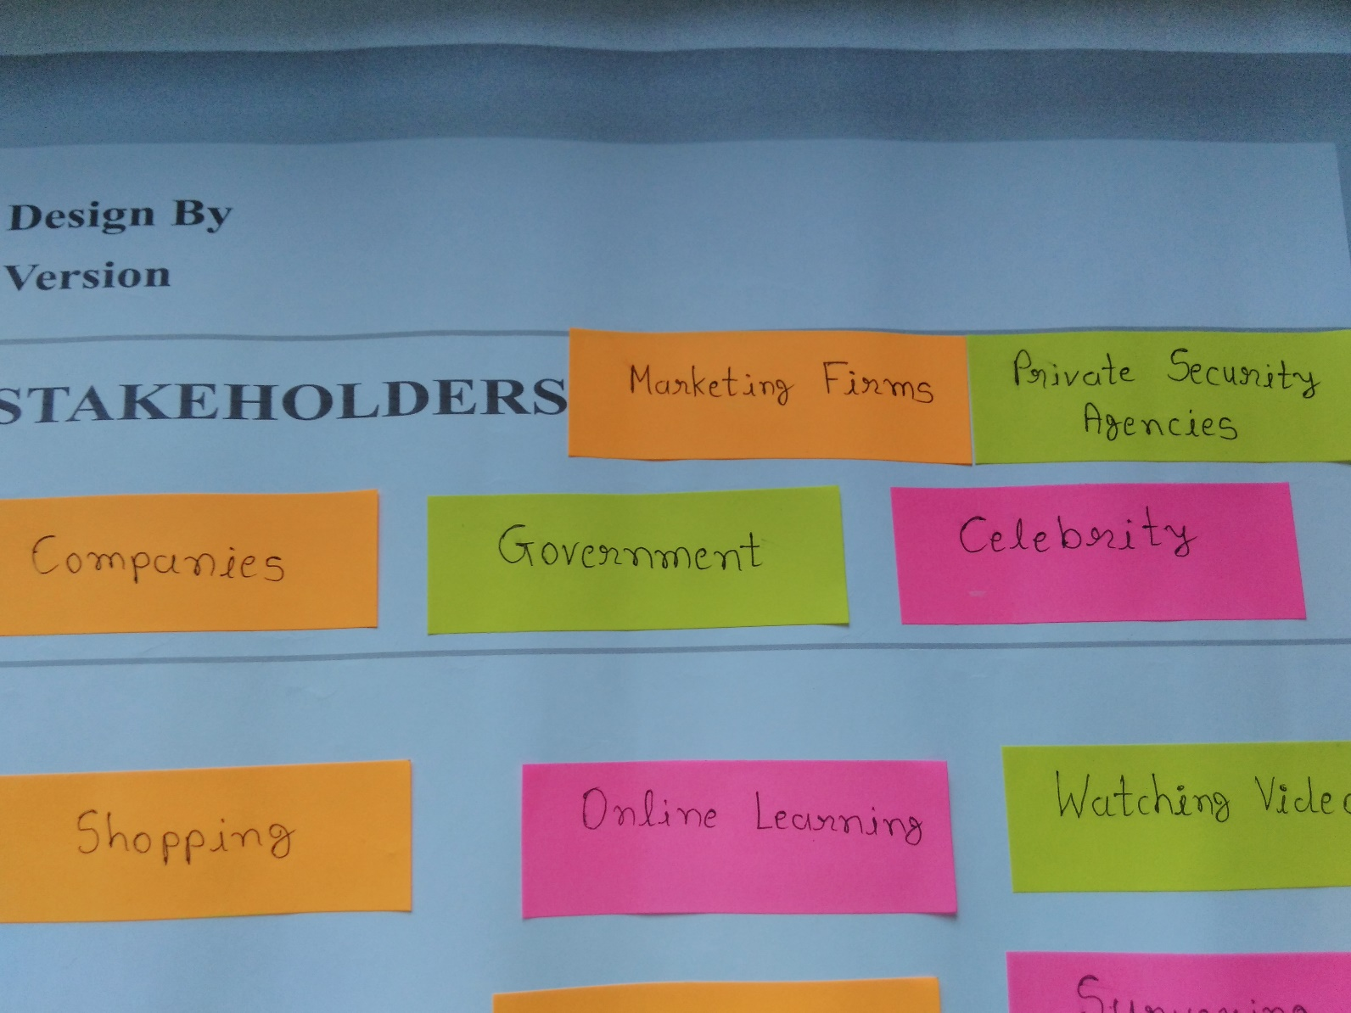

Figure 2 Stakeholders

**Activities:**

Based on interaction with user, in this section we are going to list activities that a user does throughout the day and by this we can relate our solution with user activities.

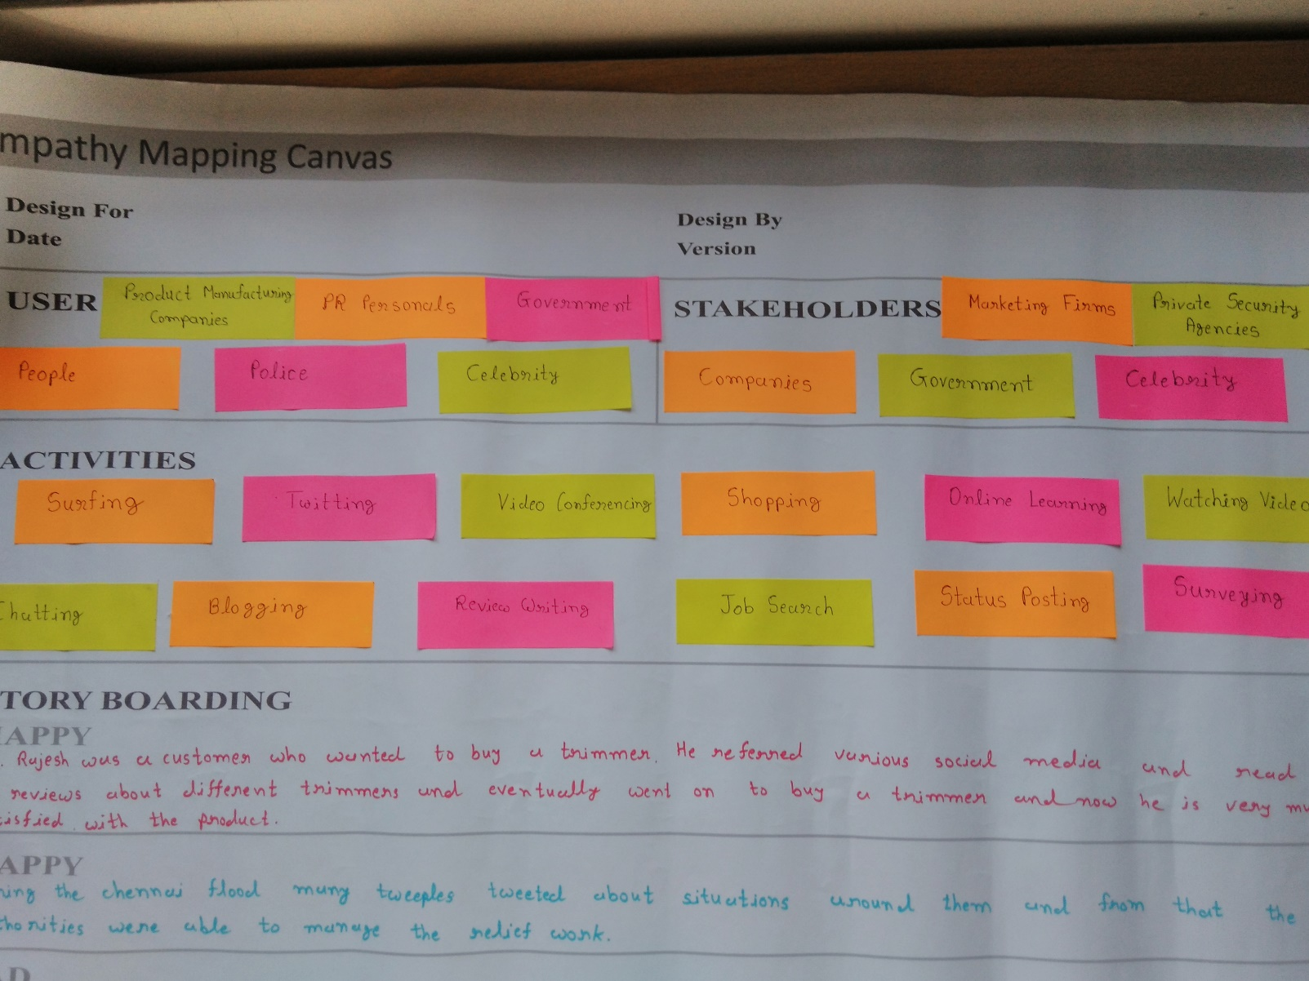

Figure 3 Activities

**Story Boarding:**

Based on interaction with user, in this section we are going to list some good and bad incidents that occurred with the users in the form of a story.

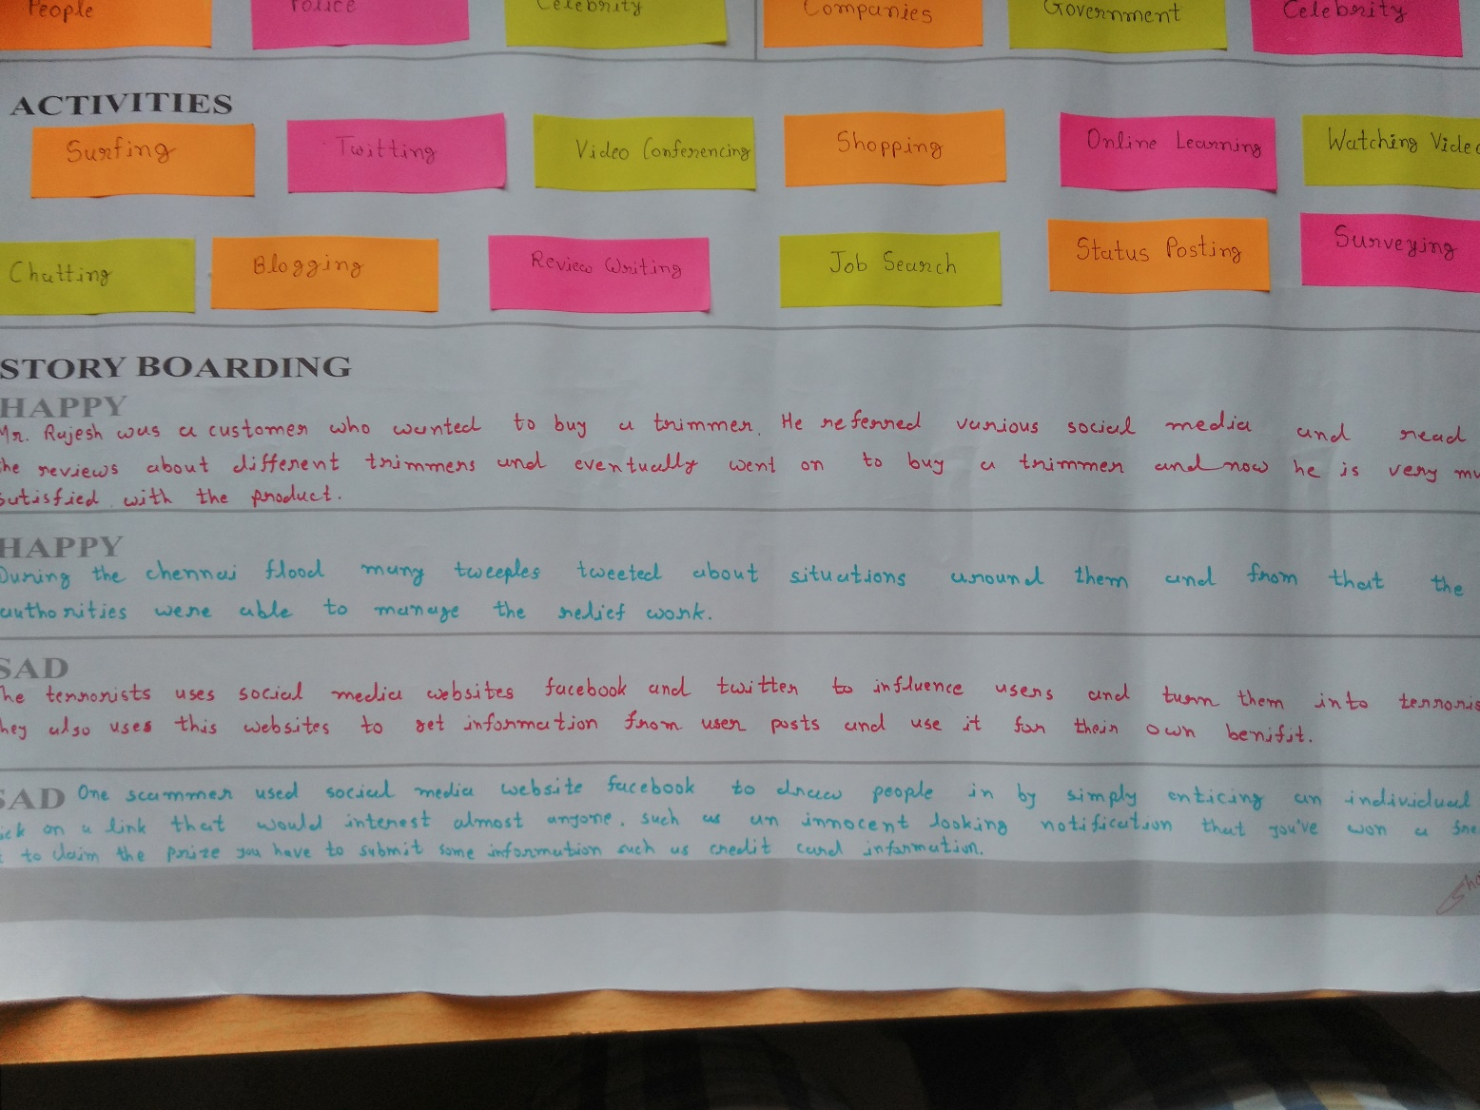

Figure 4 Story Boarding

# 2.2 Diachronic Analysis & Synchronic Analysis

### Diachronic Analysis:

* + - The time consumption of the working of the system was too much.
    - Physical work for analysis of the large data derived from the mass of people was increased so much which will decrease the accuracy and productivity of the Analysis.
    - This decrease in productivity needs some solution to make the same process easier and less time consuming.
    - This system will be able to decrease the work load of companies, marketing personnel, students, media, etc.
    - The user was not being able to analyze the live data required for the analysis.

### Synchronic Analysis:

* + - Our system is able to combine so many features in one application.
    - The features like analysis of popularity of an object, overall positive/negative reviews.
    - The information of all the documents are stored in the server.
    - The user will be able to use the analyzed data on their website.
    - This all can get in one application without any problems.
    - The multi functionality of the application helps user to get all the facilities at one place only.

2.3 **Ideation Canvas:**

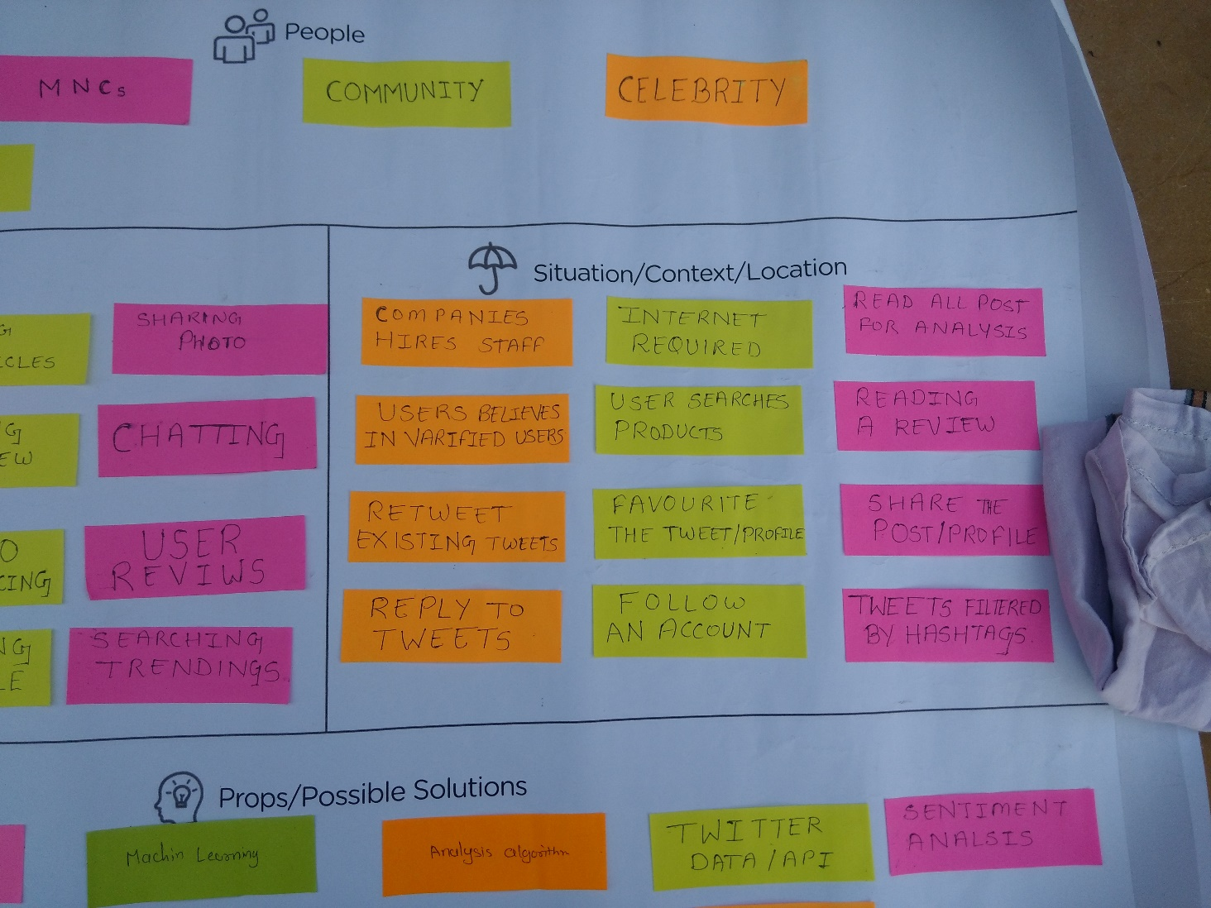

Figure 5:Ideation Canvas situation/context/location

**Situation/Context/Location:**

* Retweet Exciting Tweets
* Company hire Staffs
* User Search Product
* Reading a review
* Follow account

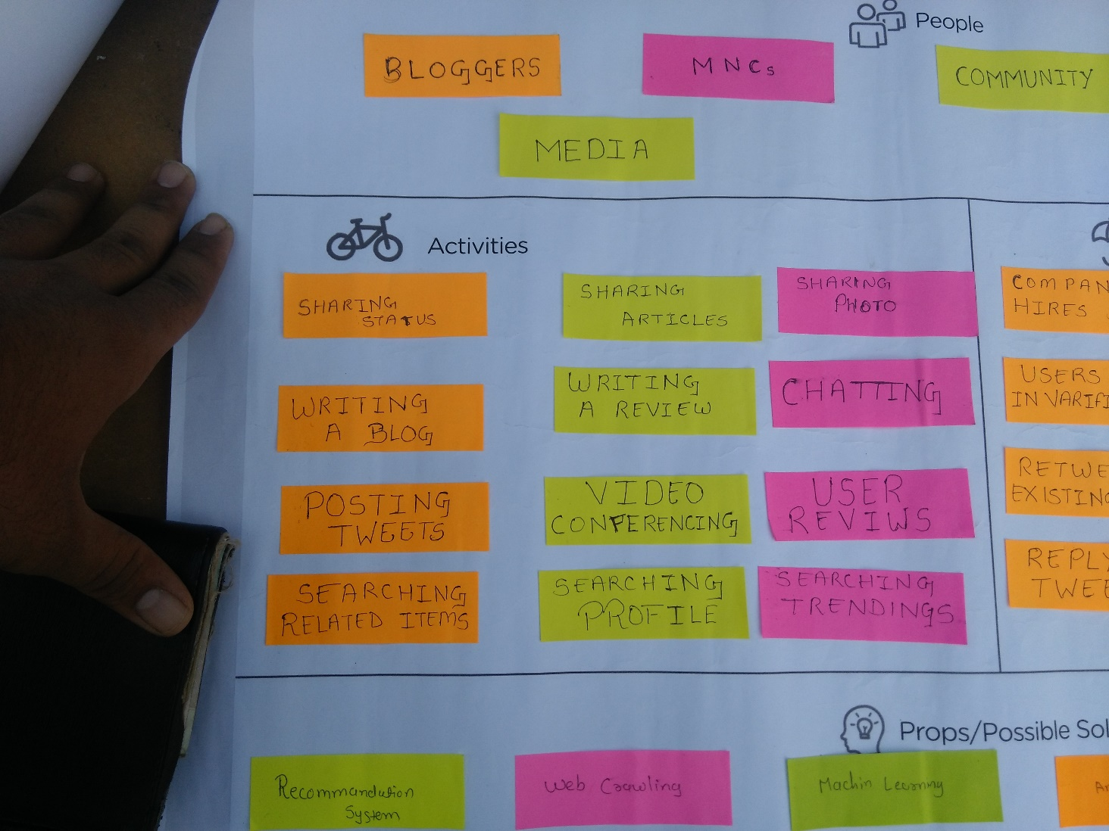

Figure 6:Ideation Canvas activities

**Activities:**

* Sharing Status
* Sharing Article
* Writing a Review
* Searching Profile
* Chatting
* Sharing photos
* Posting Tweets

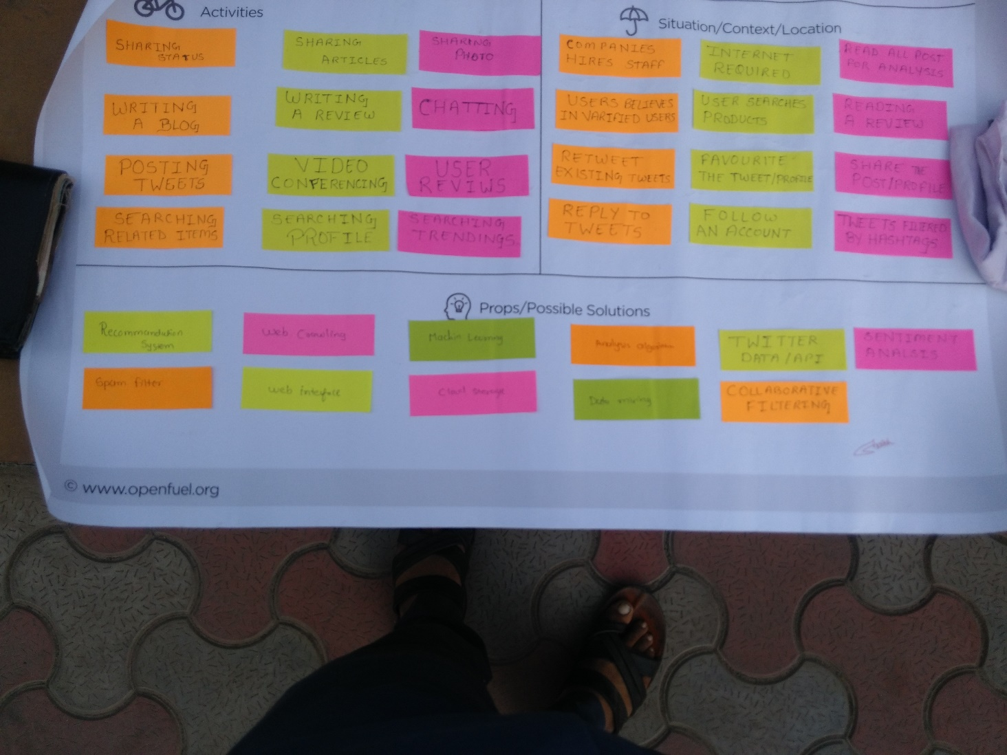

Figure 7:Ideation Canvas props/possible solutions

**Props/Possible solutions:**

* Sentiment Analysis
* Twitter Data/API
* Data mining
* Machine Learning
* Cloud Storage
* Recommendation System
* Web interface

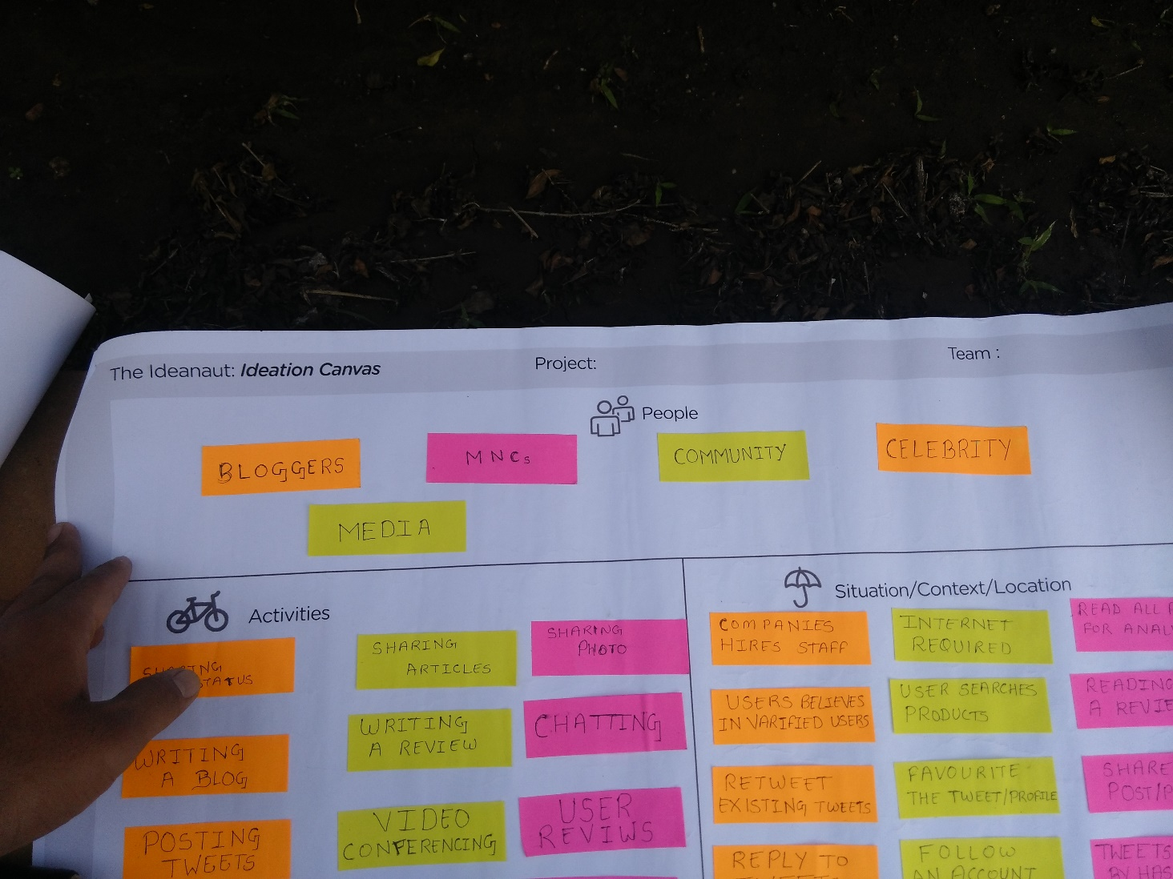

Figure 8:Ideation Canvas people

**People:**

* Blogger
* Media
* MNCs
* Celebrity
* Online Community

2.4 **Product Development Canvas**

**Product Development Canvas**

**Purpose:**

This section defines what the purpose of particular solution is. What is the purpose of a particular product?

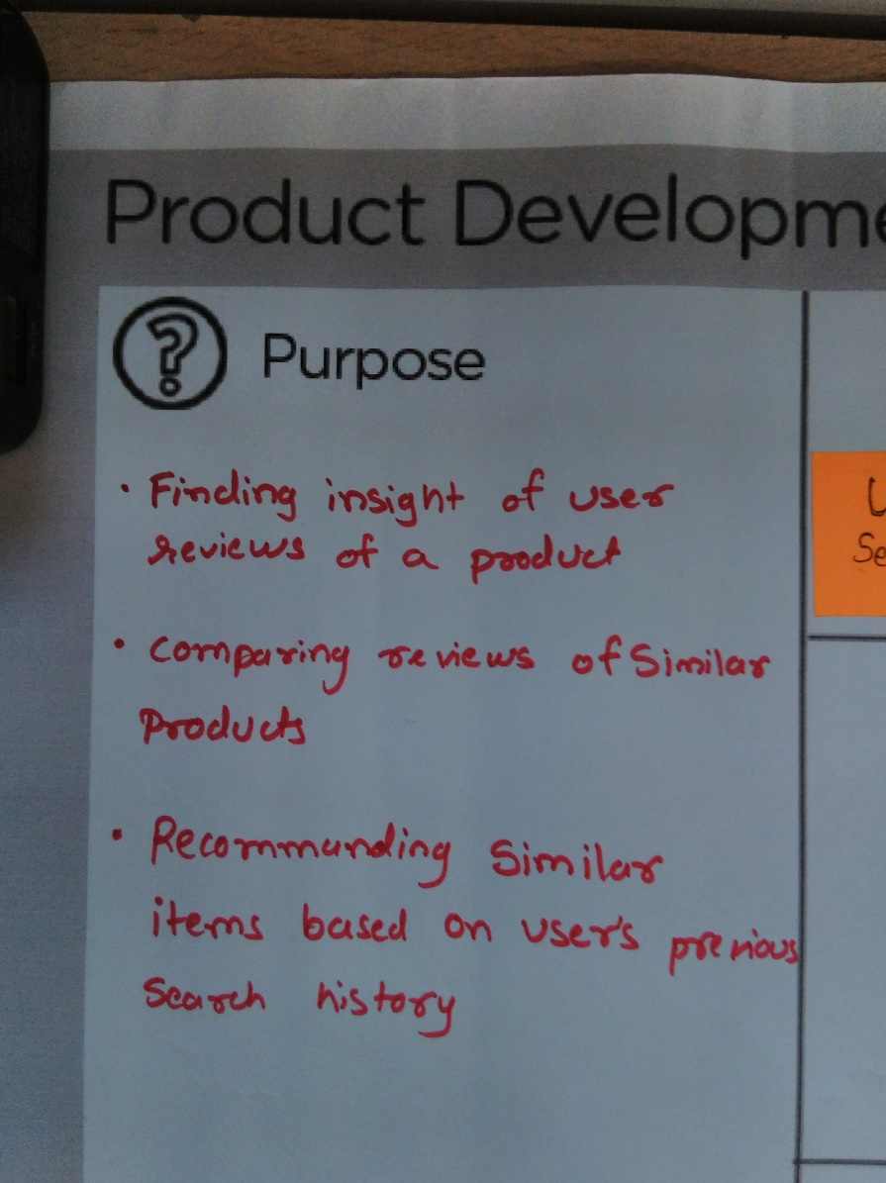

Figure 9 Purpose

**People:**

People are the users who are going to use the product or solution.

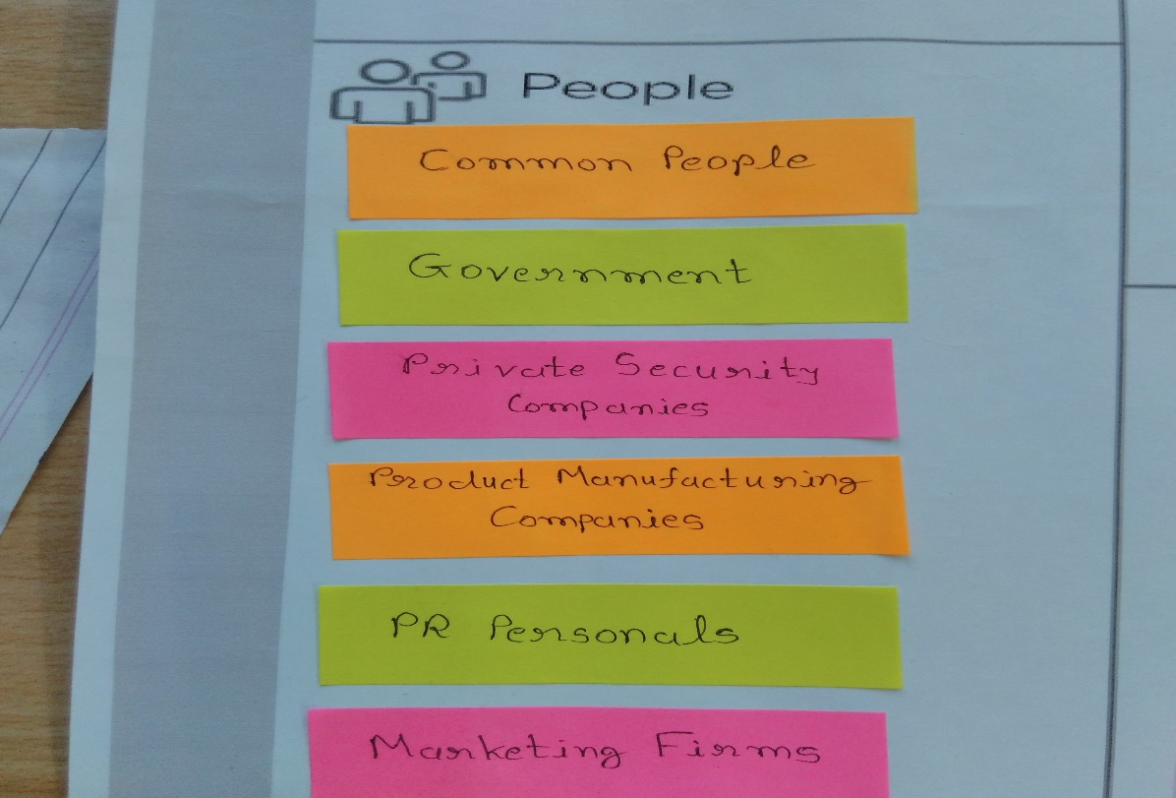

Figure 10 People

**Product Experience:**

This the review of the product when a user uses it.

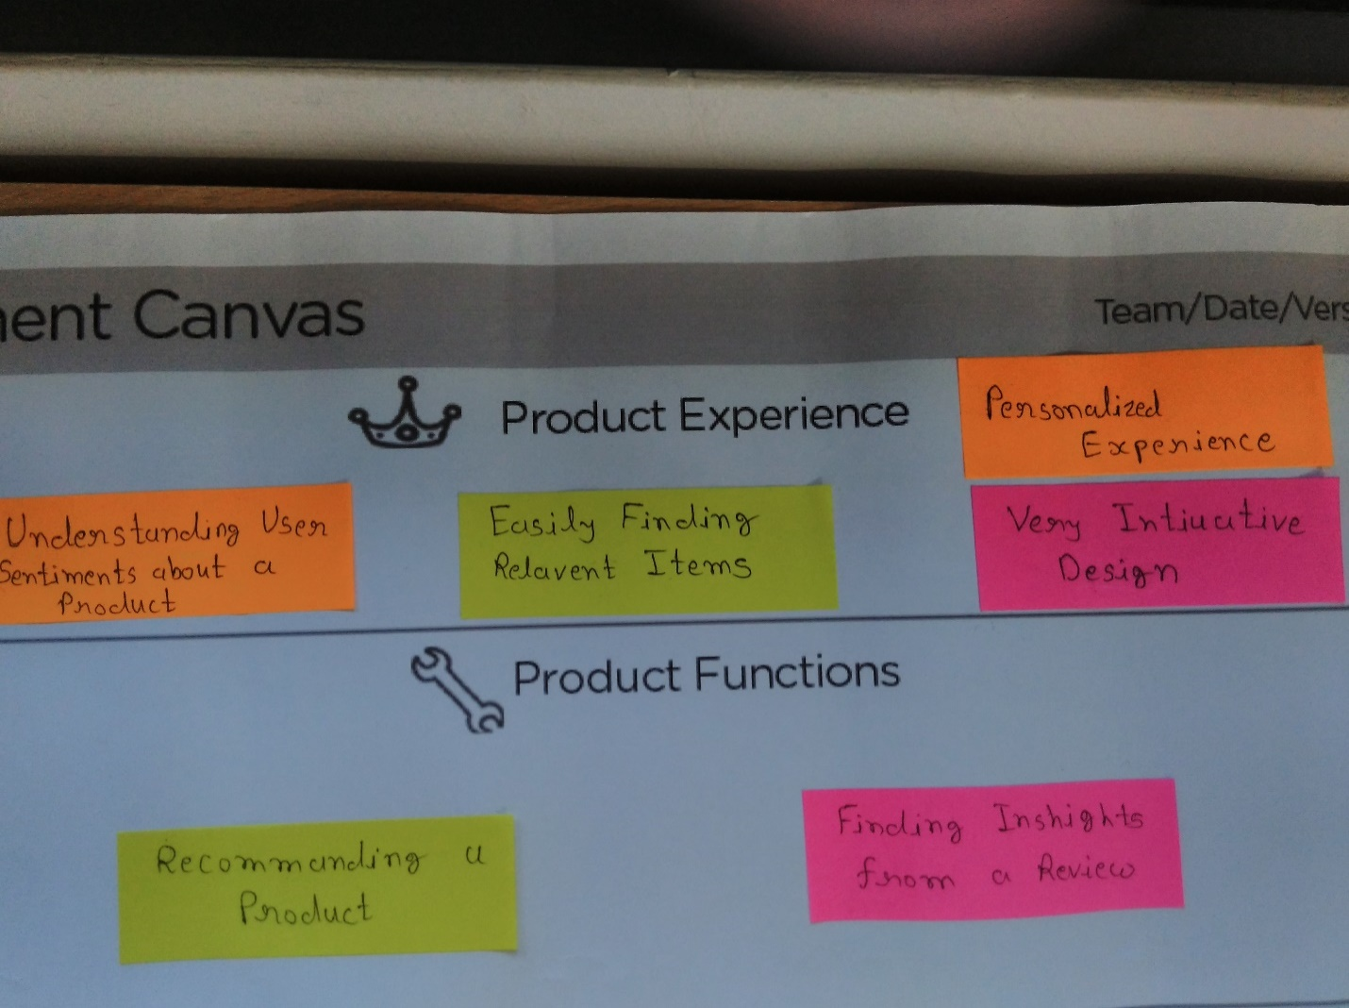

Figure 11 Product Experience

**Product Functions:**

Function describes the high level solutions of the product. It is a group of the features. This is the baseline of the solution.

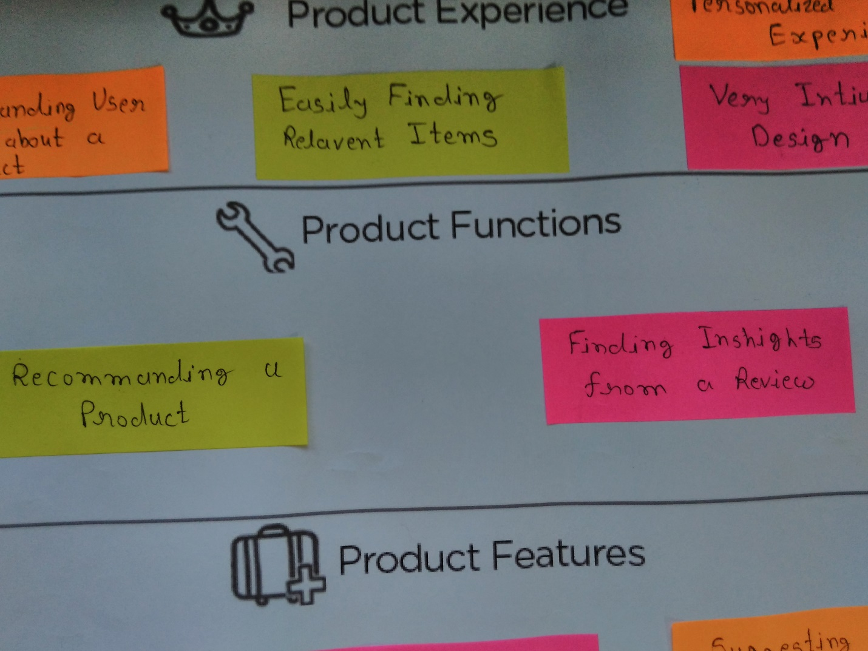

Figure 12 Product Functions

**Product Features:**

Product features are the underlying functions of the product. A single feature can be used for multiple functions.

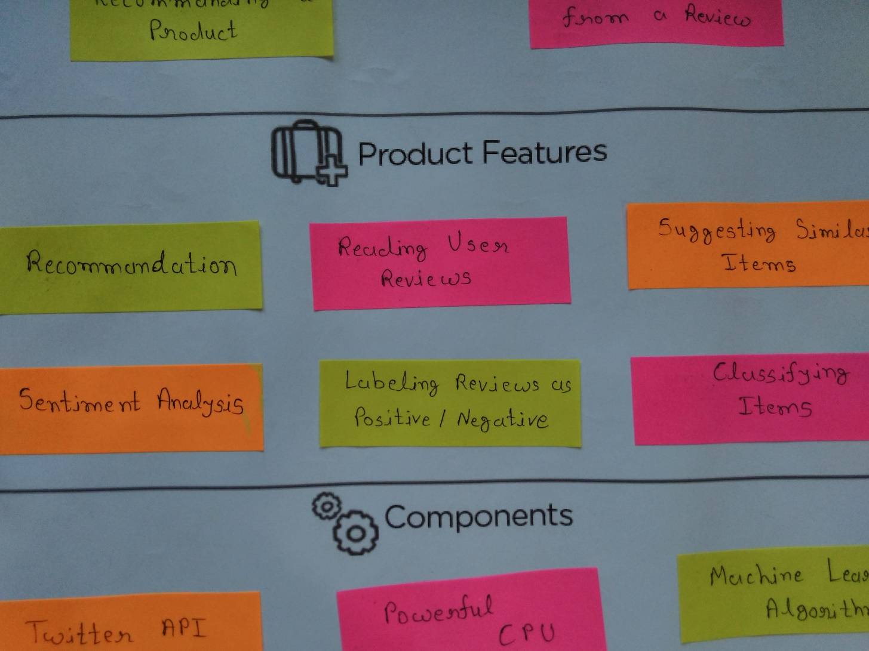

Figure 13 Product Features

**Components:**

This is the list of components which are going to be used for the features of the product. This are the objects required to fulfill a particular function of the product.

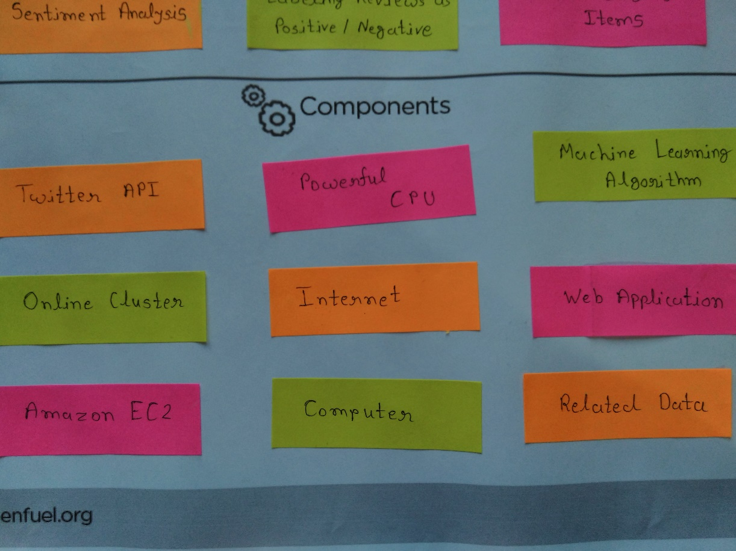

Figure 14 Components

**Customer Revalidation:**

After the prototype of the product is ready, we can take it to the user to get his feedback about the product and validate our product. In this customer suggests some changes in the product.

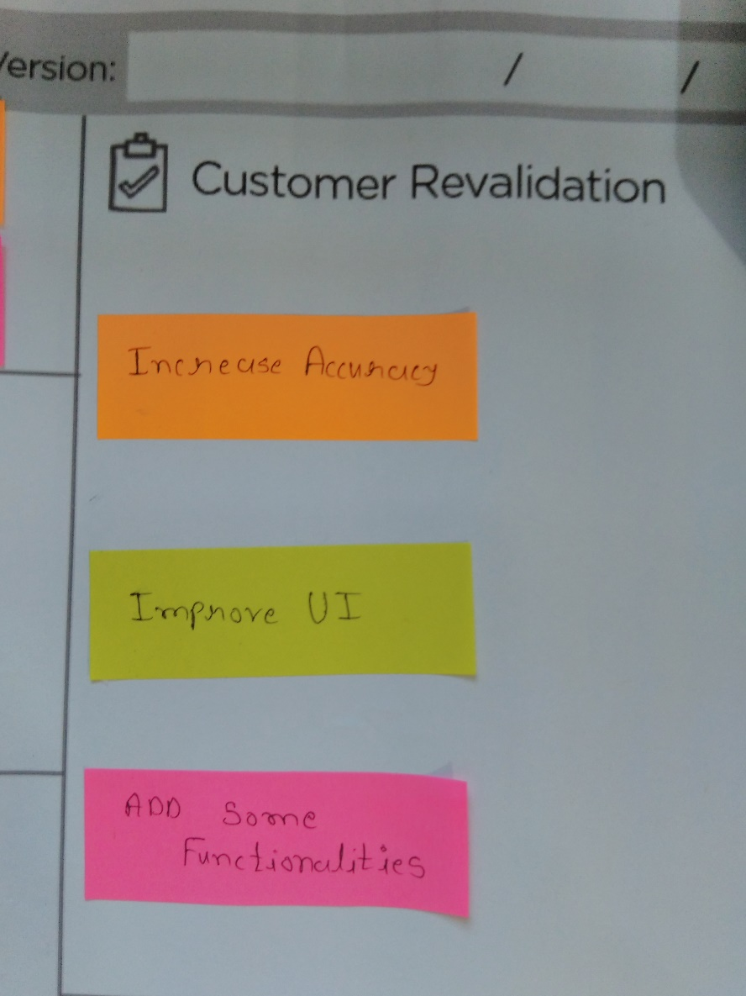

Figure 15 Customer Revalidation

**Reject/Retain/Redesign:**

After user gives his feedback, it’s up to developer to adapt the changes that are suggested by the user. They can modify the product if it is feasible and viable.

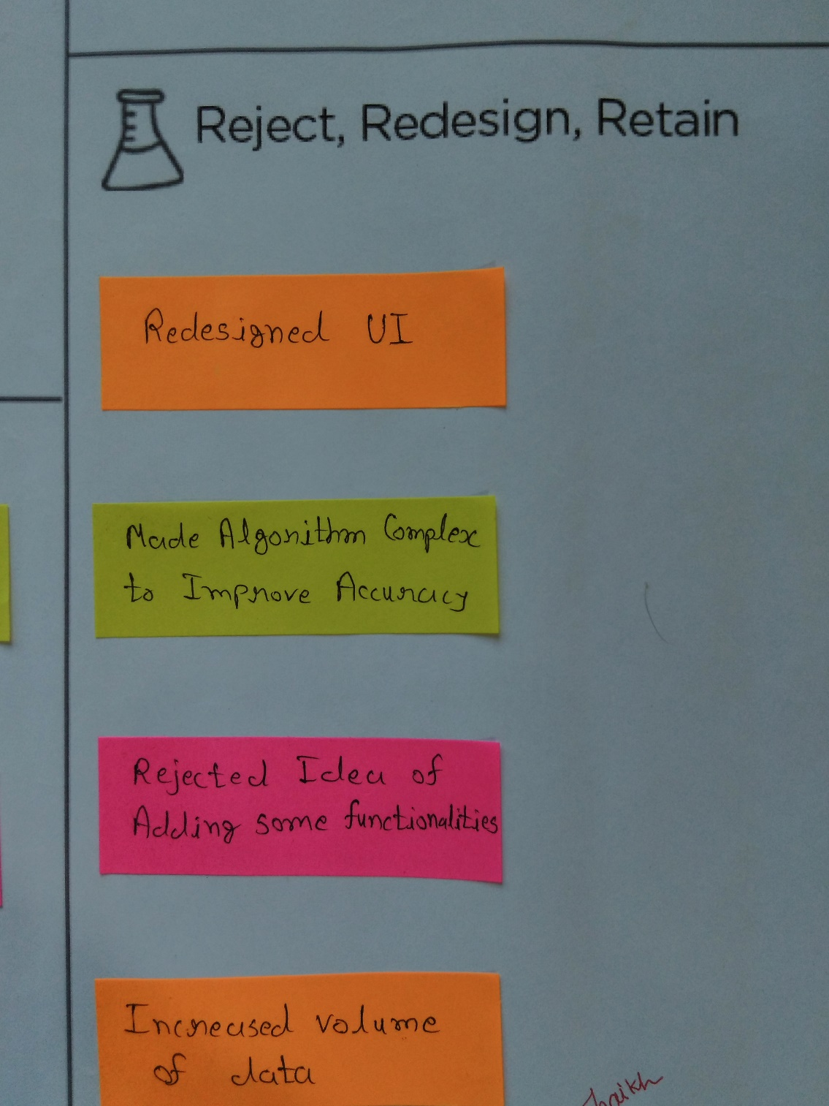

Figure 16 Reject/Retain/Redesign

**Chapter 3:** Feedback Analysis with User

**3.1 Feedback Analysis with User**

* Increase the Accuracy of the output result by RSS (Residual Sum of Square) error.
* Improve UI of the existing User Interface using Simple and interactive UI.
* Add some Functionalities to Existing Analysis Phase of Social Media data like level of sentimental analysis that are derived from the social media (here, we used Twitter).

**Chapter 4:** Summary of Findings of Prior Art Search

4.1 **Paper 1 Summary(Utsav Maniar):**

**A Few Useful Things to Know about Machine Learning**

Machine learning system can automatically learn programs form data, making them more attractive than manually constructing them. The article focused on classification algorithms. With machine learning integrated in many applications, there are many textbooks and resources but it is easy to overlook common “folk knowledge” that is needed to successfully develop applications. This article points out pitfalls to avoid, important issues to focus on, and answers to common questions.

The paper described machine learning algorithms and being made up of three main components. Representation, Evaluation, and Optimization.

1. Representation - A classifier must be represented in a formal language that the computer can handle. Creating a set of classifiers the learner can learn is crucial.
2. Evaluation - An Evaluation function is needed to distinguish good classifiers from bad ones.
3. Optimization - Finally we need a method to search among the classifiers in the language for the highest scoring one. The choice of optimization technique is key to the efficiency of the algorithm.

**Main Problem and Mitigation Strategy:**

* Over fitting is the largest problem in Machine Learning i.e. Low bias, High Variance

**Solutions:**

1. Strong false assumptions can be better than weak true ones, because a learner with latter needs more data to avoid overfitting.
2. Cross-Validation: Too many parameter choices itself can cause overfitting.
3. Regularization can penalize classifiers with more structure, promotes ones with less structure and thus avoids overfitting.
4. Chi-Squared test before adding new structure. (Determine whether adding the structure actually affects the classification).
5. Obtain more examples (data) in your training set.

* Curse of Dimensionality: Volume of the space increases so fast that the available data becomes sparse.

**Solutions:**

1. Blessing of non-uniformity: Examples are not spread uniformly.
2. Obtain more examples (data) to counter the large number of dimensions.
3. Perform dimension reduction.
4. Feature engineering: Determining which features to use is the most important factor of a successful ML algorithm.

**Generalization**

The fundamental goal of machine learning is to generalize beyond the examples in the training set. So just because you can predict something with a very high degree of accuracy from your training set, if you can’t make an accurate prediction in the real world your learner becomes obsolete.

**Paper 2 Summary(Utsav Maniar)**

**Sentiment Analysis of Twitter Data**

Microblogging websites have evolved to become a source of varied kind of information. This is due to nature of microblogs on which people post real time messages about their opinions on a variety of topics, discuss current issues, complain, and express positive sentiment for products they use in daily life. In fact, companies manufacturing such products have started to poll these microblogs to get a sense of general sentiment for their product. Many times these companies study user reactions and reply to users on microblogs. One challenge is to build technology to detect and summarize an overall sentiment.

In this paper, they had looked at one such popular microblog called Twitter and build models for classifying “tweets” into positive, negative and neutral sentiment. They build models for two classification tasks: a binary task of classifying sentiment into positive and negative classes and a 3-way task of classifying sentiment into positive, negative and neutral classes.

In this paper they introduced two new resources for pre-processing twitter data: 1) an emoticon dictionary and 2) an acronym dictionary. They prepared the emoticon dictionary by labeling 170 emoticons listed on Wikipedia with their emotional state. For example, “:)” is labeled as positive whereas “:=(” is labeled as negative. We assign each emoticon a label from the following set of labels: Extremely-positive, Extremely-negative, Positive, Negative, and Neutral. We compile an acronym dictionary from an online resource. The dictionary has translations for 5,184 acronyms. For example, lol is translated to laughing out loud.

# 4.2 Survey Paper :1(Sunny Sommanek)

**Sentiment analysis algorithms and applications:**

**A survey**

Sentiment Analysis (SA) is an ongoing field of research in text mining field. SA is the

computational treatment of opinions, sentiments and subjectivity of text. This survey paper tackles

a comprehensive overview of the last update in this field. Many recently proposed algorithms’

enhancements and various SA applications are investigated and presented briefly in this survey.

These articles are categorized according to their contributions in the various SA techniques.Machine Learning Methods:

They mention three three different machine learning algorithms who achieved great success for text categorization as in paper are as follows:

1) Naive Bayes:

Naive Bayes model is a simplest model. For the categorisation of the text this model works well. Naive Bayes classifiers assume that the effect of a variable value on a given class is independent of the values of other variable. This assumption is called class conditional independence. it is made to simplify the computation and in this sense considered as “Naive”.

2) Maximum Entropy (MaxEnt):

This model is Feature based model. MaxEnt do not make any independence assumption for its features, therefore MaxEnt is different than Naive Bayes. MaxEnt can handle features overlapping problems better than Naïve Bayes. Stanford classifier is used for classification in MaxEnt model. In practical scenarios different types of problems can be resolved by MaxEnt easily as compared to Naive Bayes.

3) Support Vector Machines (SVMs):

Support Vector Machines are theoretically well motivated algorithms and has been developed from statistical learning theory since the 60s. The class of algorithms called SVMs which are used for pattern recognition. They are effective and famous classification learning tool. Support vector machines represent an extension to nonlinear models of the generalized portrait algorithm developed by Vladimir Vapnik. The SVM algorithm is based on the statistical learning theory and the Vapnik- Chervonenkis (VC) dimension introduced by Vladimir Vapnik and Alexey Chervonenkis. Support vector machines (SVM) are a group of supervised learning methods that can be applied to classification or regression.

**Survey Paper :2(Sunny Sommanek)**

**A Survey on Twitter Sentiment Analysis with Various Algorithms**

**International Journal of Computer Applications (0975 – 8887)**

The short and simple nature of the tweets makes it easier to use and analyze. The tweets also provide a richer and more varied content of opinions and sentiments about the latest topics. Sentiment is the feeling or attitude towards something and sentiment analysis is analyzing or studying about the various reviews given by people. The process of Sentiment Analysis tends to understand these opinions and categorize them into positive, negative, neutral.

Many of the organizations are putting their efforts in finding the best system for sentiment analysis. Some of the algorithms give good results but still many more limitations in these algorithms. As the twitter users are increasing day by day and the posts shared by the people are short messages (tweets) it can be very useful to analyze its data set. There are many techniques developed to do sentiment analysis but the problems sarcasm is still not solved. The traditional way is very complex and time consuming but the recent approaches mentioned in this survey paper are quite simpler and efficient. More researches are done using SVM classifier, and also improvising its efficiency by introducing new rules and solving parsing problem. Fuzzy logic helps sentiment analysis provide efficient results as it is based on reasoning on the approximate values. Sentiment analysis when used with fuzzy logic helps to take decisions effectively but sometimes it may differ from the real time values. Future work may combine many different types of techniques to overcome

**Chapter 5: Learning from Design Thinking**

Design Thinking

is a **human-centered** approach to innovation

*that draws from the designer's toolkit to integrate*

*the* ***needs of people****,*

*the* ***possibilities of technology****,*

*and the* ***requirements for business success***

With Design Thinking, we can build the bridges to cross over the other side to that new land of promised future, so we can reliably manufactured our own Miracles.

* Encourages creative consideration of a wide array of *innovative solutions*
* Can be applied to *any field*, including higher education
* Approaches challenges from the *point of view (POV)* of the *end user*
* Calls for a deep understanding of that *user’s emotional needs*

It is a *skill* that allows a *Designer* to align what people want with what can be done, and produce a viable business strategy that creates customer value and market opportunity.

* It increases our ability of
* Discovery
* Reframe Opportunity
* Creative Ideas
* Innovation
* Art and Design
* Observation

### Chapter 6: Validation and Refinement using Prototype

Based on the User validation, we have concluded that we will modify, retain few things that we came across after User reviews on our existing update of this project.

Features like Detailed analysis of Tweets categorized by various countries, regions, communities, economical entities should be added.

Features like Sentimental analysis graph, SA meter, recommendation system will be retained.

# Conclusion/Future Scope

# As our project is based on fundamental of machine learning, which is emerging field and vast & Deep area .so by adding and working deep in project predicting & Modeling: social Media. We will make it useful to all type of audience.

**References**

[1] Apoorv Agarwal, Boyi Xie, Ilia Vovsha, Owen Rambow, Rebecca Passonneau, “**Sentiment Analysis of Twitter Data**”, Department of Computer Science, Columbia University, New York, NY 10027 USA

[2] Pedro Domingos, “**A Few Useful Things to Know about Machine Learning**”, Department of Computer Science and Engineering, University of Washington, Seattle, WA 98195-2350, U.S.A.

[3] Purva Mestry, Shruti Joshi, Sonal Mehta, Ashwini Save, “**A Survey on Twitter Sentiment Analysis with Various Algorithms**”, VIVA Institute of Technology, Virar, India

[4] Varsha Sahayak, Vijaya Shete, Apashabi Pathan, “**Sentiment Analysis on Twitter Data**”, *Department of Information Technology, Savitribai Phule Pune University, Pune, India*

**APPENDIX – A**

* Product Development Canvas

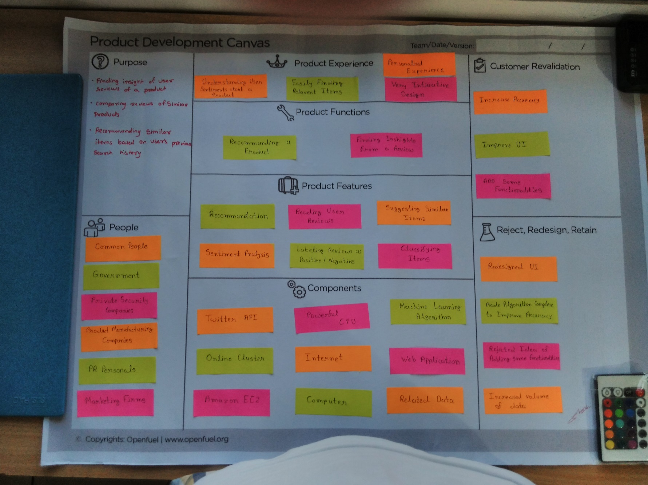

* Ideation Canvas

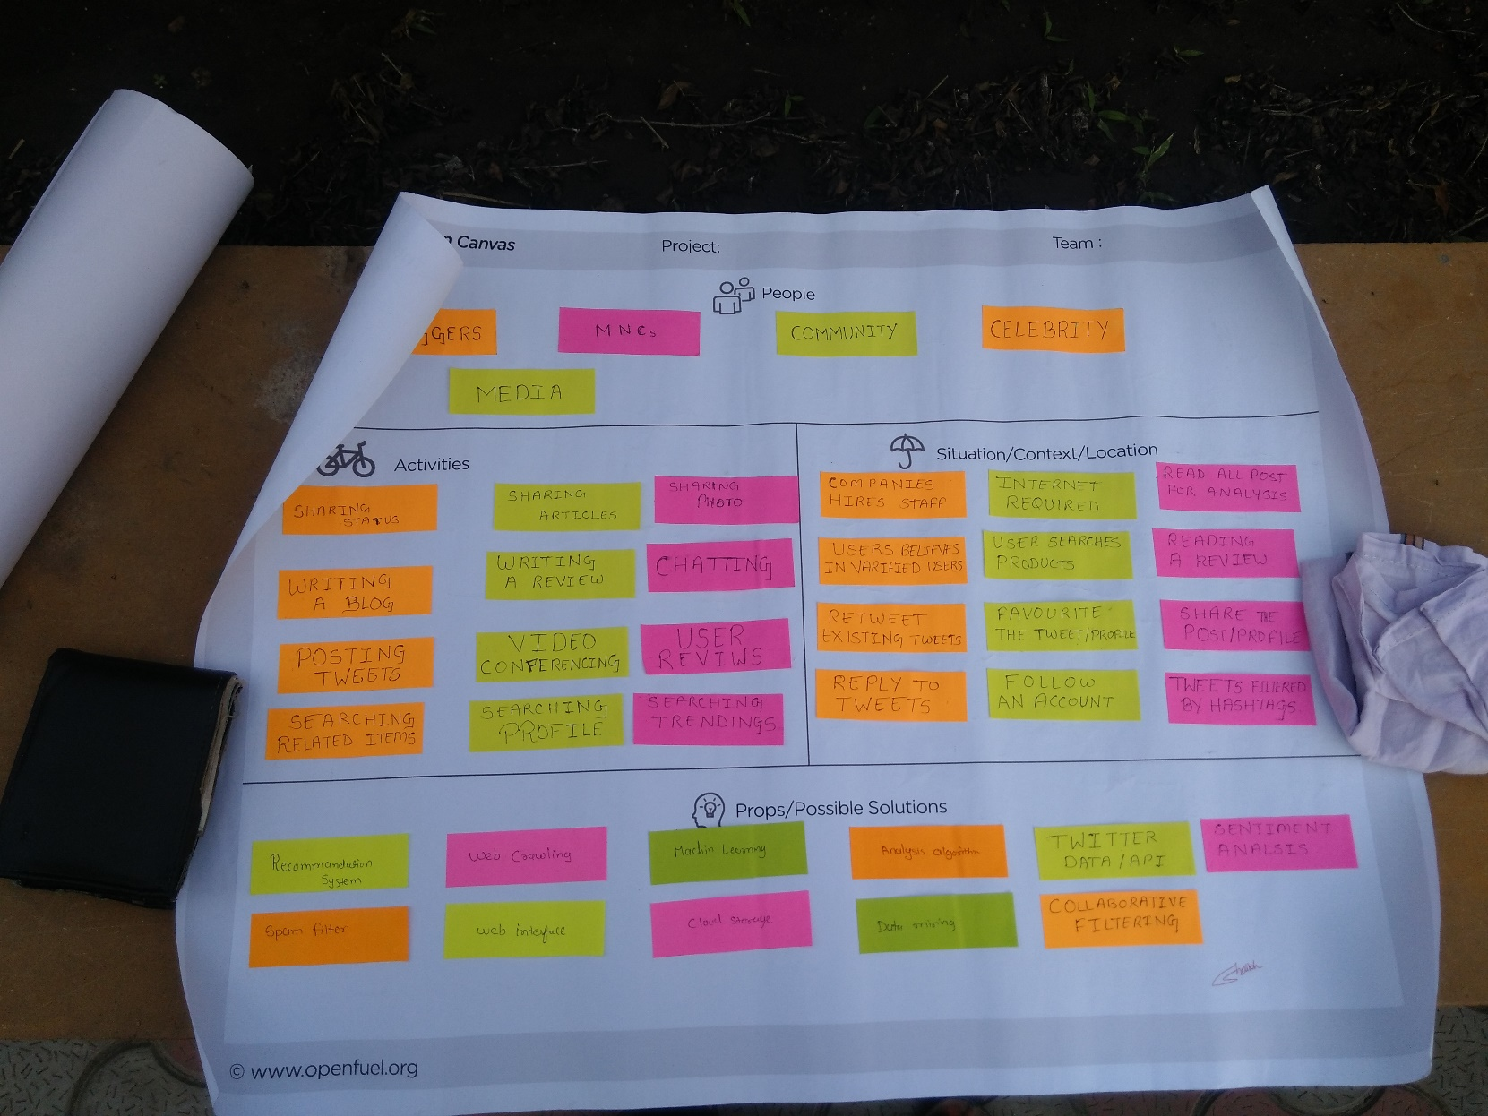

* Empathy Mapping Canvas

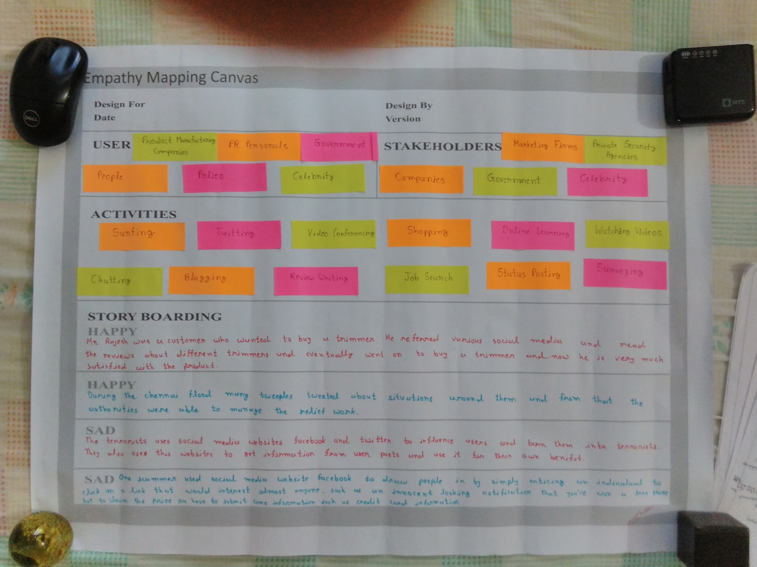

* AEIOU Summary

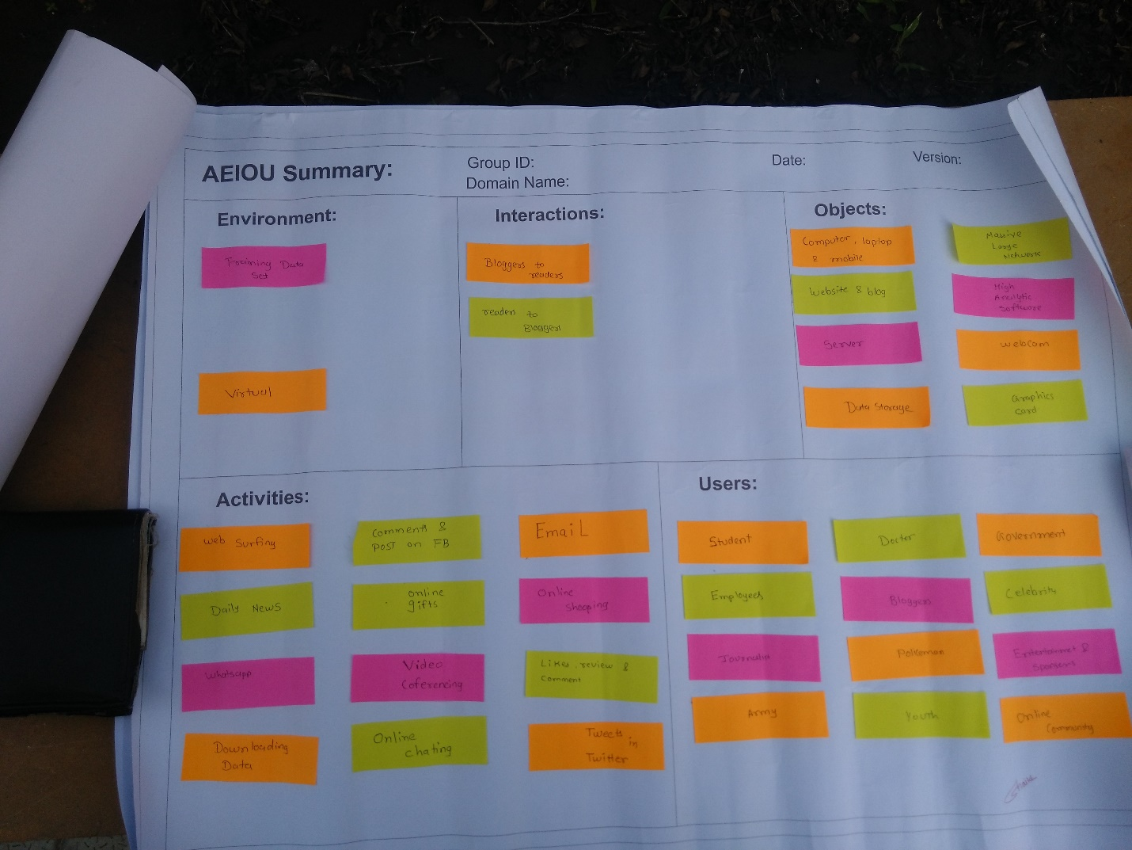

* Mind Map

